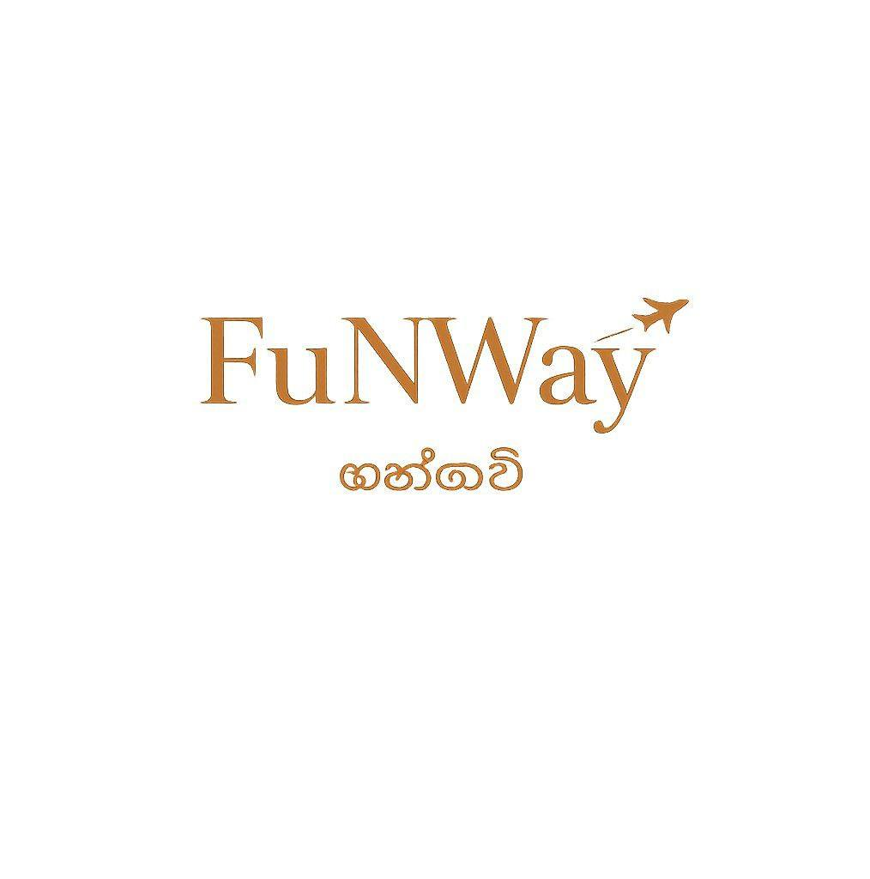

TRAVEL SERVICES AGREEMENT
Under the Laws of the Democratic Socialist Republic of Sri Lanka
FUNWAY HOLIDAYS (PVT) LTD
Registration No: PV 00202574
Registered Office:
367, 3rd Floor, Jana Jaya City,
Rajagiriya, Sri Lanka
Bank Details:
Account Name: FUNWAY HOLIDAYS (PVT) LTD
Bank: Sampath Bank PLC
Branch: No. 591A, Galle Road, Colombo 06
Account Number: 003610011135
CLIENT DETAILS
Full Name: ____________________________________________
Passport Number: ______________________________________
Nationality: ___________________________________________
Address: ______________________________________________
Phone / WhatsApp: _____________________________________
Email: ________________________________________________
This Agreement is entered into between FUNWAY HOLIDAYS (PVT) LTD (“Company”) and the above-mentioned Client (“Client”).
By signing this Agreement and/or making payment for the tour, the Client confirms acceptance of all terms, conditions, cancellation policies, liability limitations, and travel conditions stated herein.
1. Booking Confirmation
A booking shall be considered confirmed only after receipt of the required deposit and written confirmation issued by the Company.
2. Payment Terms
A standard deposit of 30%–40% of the total tour cost is required unless otherwise specified. The remaining balance must be paid no later than 30–45 days prior to arrival. Full advance payment may be required for peak seasons, special permits, festivals, palace hotels, restricted regions, or high-demand services.
3. Pricing
Prices are based on current taxes, exchange rates, supplier tariffs, fuel costs, transportation charges, and governmental levies applicable at the time of quotation. The Company reserves the right to revise pricing prior to full payment if significant changes occur beyond its reasonable control.
4. Travel Insurance
Comprehensive travel insurance is strongly recommended and may be mandatory for certain destinations. Insurance should include medical expenses, emergency evacuation, cancellation, baggage loss, and personal liability.
5. Health & Fitness
The Client confirms responsibility for ensuring adequate medical fitness for travel. Certain destinations may involve mountain roads, high altitude, remote areas, or physically demanding conditions.
6. Cancellation Policy
Cancellation requests must be submitted in writing via email.
• 60 days or more before arrival: Deposit refundable.
• 59–30 days before arrival: 50% of total tour cost retained.
• 29–15 days before arrival: 75% retained.
• 14 days or less before arrival or no-show: 100% non-refundable.
Issued air tickets, permits, monument tickets, palace stays, festival registrations, and prepaid supplier services may remain fully non-refundable according to supplier policies.
7. Refund Processing
Refunds, where applicable, shall be processed within approximately 21–30 banking days after receipt of refundable amounts from suppliers. Bank charges, transfer fees, and exchange rate differences shall be deducted.
8. Role of the Company
The Company acts solely as a travel organizer, facilitator, and coordinator between the Client and independent third-party service providers including hotels, airlines, transport providers, guides, and excursion operators.
9. Limitation of Liability
To the maximum extent permitted under Sri Lankan law, the Company shall not be liable for delays, cancellations, weather disruptions, political disturbances, force majeure events, accidents, illness, baggage loss, missed connections, or acts and omissions of third-party suppliers.
10. Force Majeure
The Company shall not be responsible for delays, changes, or non-performance caused by natural disasters, pandemics, governmental restrictions, road closures, civil unrest, strikes, adverse weather conditions, or transport disruptions beyond reasonable control.
11. Itinerary Changes
The Company reserves the right to reasonably modify itineraries, accommodations, transportation, or sightseeing arrangements where necessary for operational, safety, weather, or logistical reasons.
12. Client Responsibilities
The Client is responsible for ensuring valid passports, visas, permits, vaccinations where applicable, and compliance with immigration and customs regulations.
13. No Refund for Unused Services
No refunds shall be payable for unused services, voluntary withdrawal from the tour, missed sightseeing, or early departure after commencement of services.
14. Governing Law & Jurisdiction
This Agreement shall be governed by the laws of the Democratic Socialist Republic of Sri Lanka. Any disputes arising under this Agreement shall fall under the exclusive jurisdiction of the competent courts of Sri Lanka.

Client Signature: ________________________________
Date: ____________________________________________
Authorized Representative: ________________________
FUNWAY HOLIDAYS (PVT) LTD

